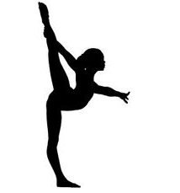
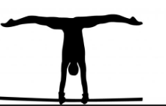

M.A.B Gymnastics Academy
After School Club

Exciting news – M.A.B Gymnastics sessions will return next term for Year 1 and above from Thursday 9th September -16th December 2021.

Thursday sessions, 3.30 – 4.15 pm: 14 x £3.50 = £49.00

Payment must be made via bank transfer (sort code: 560060, account number: 41513487, please put your child’s name and school as the reference).

Places are limited. To secure a place please email: gymnasticsacademy@hotmail.com

Many thanks,

Mikaela Bates

………………………………………………………………………………………………………………………………………
M.A.B Gymnastics Academy After School Club return slip:
Child’s Name:……………………………………………………. Child’s DOB:…………………..……….….
Child’s School:…………………………………. Any Medical Conditions:………………..…..………..
Any additional needs:……………………………………………………………………………………..………….
Emergency Contact Name:…………………… Emergency Contact Details:………..………….
Email:……………………………………………………………………………………………………………...………….

Please note, there will be an additional late pick-up fee of £5. Please let coaches know if you are not able to collect your child on time.

Signed:…………………………………………………..………Date:…..………………………………………………

Please tick if you agree for the club to send club news and information about gymnastics activities that you might be interested in.

M
B
GYMNASTICS
A

M.A.B Gymnastics – COVID Club Rules

We are excited to be able to return to our gymnastics classes! Whilst COVID-19 restrictions have been lifted we will still be following certain procedures to help keep your child safe. Please read through each point below with your child.

- If you are feeling unwell or displaying COVID symptoms, please do not attend the session.
- Hand gel will be provided upon arrival to your session.
- Once in the hall there will be cones marking where to put your belongings.
- During the session, we will mainly be working on individual skills so that everyone can keep a safe distance apart. If any group work is undertaken children will remain in their year groups.
- The hall will be ventilated at all times.
- All fees must be paid online at the start of term. We will not be taking any cash.
- Please provide up-to-date contact details.

Thank you for your understanding and support!

If you have any questions or concerns, please do not hesitate to contact us.

Many thanks,

Mikaela
Head Coach

