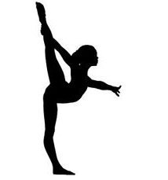
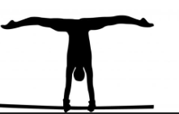
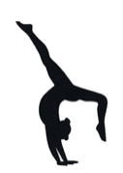

M.A.B Gymnastics Academy
After School Club

M.A.B Gymnastics sessions will return next term for Year 1 and above from Thursday 21st April – 21st July 2022.

Thursday sessions, 3.30 – 4.15 pm: 13 x £4.00 = £52.00

Payment must be made via bank transfer (sort code: 560060, account number: 41513487, please put your child’s name and school as the reference).

Places are limited. To secure a place please email: gymnasticsacademy@hotmail.com

Many thanks,

Mikaela Bates

………………………………………………………………………………………………………………………………………
M.A.B Gymnastics Academy After School Club return slip:
Child’s Name:……………………………………………………. Child’s DOB:…………………..……….….
Child’s School:…………………………………. Any Medical Conditions:………………..…..………..
Any additional needs:……………………………………………………………………………………..………….
Emergency Contact Name:…………………… Emergency Contact Details:………..………….
Email:……………………………………………………………………………………………………………...………….

Please note, there will be an additional late pick-up fee of £5. Please let coaches know if you are not able to collect your child on time.

Signed:…………………………………………………..………Date:…..………………………………………………

Please tick if you agree for the club to send club news and information about gymnastics activities that you might be interested in.

