CHILD CRIMINAL EXPLOITATION

What is Child Criminal Exploitation?
- Child Criminal Exploitation (CCE) is a type of child abuse. It occurs where an individual or group takes advantage of an imbalance of power to coerce, control, manipulate or deceive a child or young person under the age of 18 into any criminal activity.
- In exchange for something the victim needs or wants
- For the ﬁnancial or other advantage of the perpetrator or facilitator
- Through violence or the threat of violence.

COUNTY LINES & CCE

Criminal exploitation often happens within the context of county lines activity. The Home Ofﬁce deﬁnes county lines as: ‘The police term for urban gangs supplying drugs to suburban areas and market and coastal towns using dedicated mobile phone lines or “deal lines”. It involves child criminal exploitation (CCE) as gangs use children and vulnerable people to move drugs and money. Gangs establish a base in the market location, typically by taking over the homes of local vulnerable adults by force or coercion in a practice referred to as “cuckooing”.’

SIGNS YOU MAY NOTICE IF A CHILD IS BEING CRIMINALLY EXPLOITED

- Regularly absent (often unexplained) from and struggling at school
- Going missing from home, staying out late and travelling for unexplained reasons
- In a relationship or hanging out with someone older than them
- Being isolated or withdrawn
- Having unexplained amounts of money and buying new things
- Wearing clothes or accessories in gang colours or getting tattoos
- Using new slang words
- Being angry, aggressive or violent
- Spending more time on social media and being secretive about time online
- Increase number of calls or sending more texts, possibly on a new phone or phones
- Self-harming and feeling emotionally unwell
- Substance misuse and drinking alcohol
- Committing low level crimes like shoplifting or vandalism
- Unexplained injuries and refusing to seek medical help
- Carrying weapons or having a dangerous breed of dog

GROOMING

Grooming is when someone builds a relationship, trust and emotional connection with a child or young person so they can manipulate, exploit and abuse them.

Children and young people who are groomed can be sexually abused, exploited or trafﬁcked.
Anybody can be a groomer, no matter their age, gender or race. Grooming can take place over a short or long period of time – from weeks to years. Groomers may also build a relationship with the young person's family or friends to make them seem trustworthy or authoritative.

THE DANGERS OF CRIMINAL EXPLOITATION

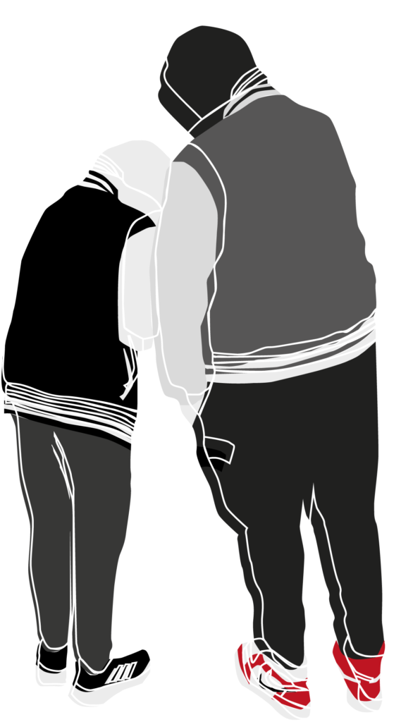
- subjected to threats, blackmail and violence
- being arrested
- theirs, family and friends safety threatened
- risk of emotional abuse
- substance and alcohol misuse
- forced to commit crimes
- not being able to leave or cut off ties with the gang
- risk of physical harm, rape and sexual abuse
- risk of being killed or severely injured
- signiﬁcant negative impact on education and future employment

ASK FOR HELP AND ADVICE
The Police: If your child is in immediate danger, call the police.

Parents Against Child Exploitation (PACE): Support and advice around CCE and CSE.
The NSPCC: The NSPCC have a helpline where you can talk to a trained professional about what is happening and signpost you to the services in your area. [help@nspcc.org.uk]
Fearless: You can report a crime anonymously at Fearless.

Justice & Care: One of our dedicated Victim Navigators can be contacted for advice and support, for you and your child.
Your local Navigator is Ellie: 07522547793

