4th January 2023
Dear Parents and Guardians,
As your child returns to school after the festive break, it is important you are aware that there remains a risk of winter infections. You may have seen or heard that Flu, COVID-19, and Scarlet Fever are continuing to circulate, and as a result there is an increased risk of infection amongst the school community.
Professor Susan Hopkins, the Chief Medical Adviser at the UK Health Security Agency (UKHSA) has issued the following advice to help protect your child and others they are in contact with:
- If your child is unwell and has a fever, you are advised to keep them at home until the fever has passed and they feel better. During this time your child should avoid attending school, nursery, childminder or having contact with any other person outside the household.
- An adult who is unwell should also try to stay at home and avoid seeing others.
- If a person is unwell and they have to go out, they are advised to avoid attending a healthcare setting, such as a GP surgery or hospital, unless calling first. Also do not attend a high-risk setting such as a care home or nursing home.
- If a person needs to leave the house whilst they are unwell, UKHSA recommends a face covering is worn at all times to help avoid passing their infection to others.
- Good hand hygiene continues to be important to avoid spreading infections through touch. You are asked to encourage your child to regularly wash their hands, with soap and warm water.
- Vaccination is the best protection against any avoidable illness such as Flu or COVID-19. You are advised to ensure your child is vaccinated when they are invited.
For more information about getting your child vaccinated against Flu visit: https://www.nhs.uk/conditions/vaccinations/child-flu-vaccine/.
For more information about the Covid-19 vaccination visit: https://www.nhs.uk/conditions/coronavirus-covid-19/coronavirus-vaccination/.

The Public Health Team of West Northamptonshire Council urges you to follow this advice, to help keep your child, their school community, and the local population safe.
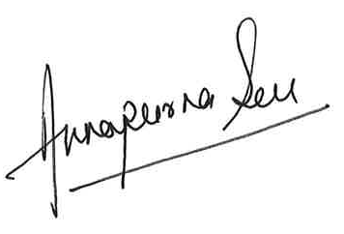
Dr Annapurna Sen
Public Health Physician - Health Protection Specialist
Public Health West Northants Council
On behalf of North Northants and West Northants Councils

